The Rise of the Researcher-as-Maker: Crafting Bespoke Analytical Tools with AI
Author: Jaeyoon Jacob Ahn, Senior Researcher / Producer, Direct Research Korea

1. Executive Summary
The most transformative shift in market research today is the quiet revolution of researchers learning to build their own tools. Analysts are no longer waiting for standardized software to process their data; instead, they are designing lightweight, reusable instruments that match their specific research purpose. This paper showcases how this "Maker" movement—supported by agentic platforms like Google Antigravity—is reshaping the speed and depth of insight generation in the gaming industry. By building bespoke tools to navigate local communities like Inven, researchers can now perform complex feature-based classification, time-series sentiment mapping, and churn analysis with unprecedented precision, reclaiming the interpretive craft of research from "black box" algorithms.

2. Introduction: The Evolution of the Research Craft
The Imperative for Speed in Gaming Insights
In the rapidly evolving landscape of the gaming industry, the imperative to garner swift and accurate insights about player reactions to new releases has never been more critical. Traditional market research methods often struggle to keep pace with the dynamic nature of gaming communities, where sentiment can shift within hours of a patch or launch.
The "Maker" Paradigm Shift
Two years ago, we explored how Custom-GPT models could analyze qualitative data. Today, we move beyond analysis toward Agentic Tool Building. The "Researcher-as-Maker" does not just use AI; they build with it. Using platforms like Antigravity Browser Control, researchers can now automate the entire lifecycle of a study—from navigating complex community boards to performing longitudinal sentiment analysis—without being constrained by the feature sets of commercial software.

3. The Evolution of Market Research and AI
From Manual Surveys to Agentic Research (20th Century – 2026)
- Early Beginnings: Foundational methods relied on direct consumer surveys and observational studies, which were time-consuming and limited in scope.
- The Digital Revolution: The internet introduced "big data" from social media analytics and e-commerce, but researchers remained dependent on technology providers for analysis.
- The Custom-GPT Milestone: Generative AI allowed for the analysis of vast qualitative data with human-like text generation.
- The Agentic Era (Present): The breakthrough lies in Browser Control. Researchers now use agents to act as their "hands and eyes" on the web, navigating niche communities and building their own analytical dashboards through "Vibe Coding".

4. Core Technology: Google Antigravity Browser Control
For a researcher to become a "Maker," they need a tool capable of navigating the "Deep Web" of consumer sentiment. Antigravity provides this through:
4.1. Autonomous Browser Actuation.
Unlike standard scrapers that download static HTML, Antigravity operates a real browser. It can log in to communities, click "Load More" on thousands of comments, and handle dynamic JavaScript elements that define modern gaming boards.
4.2. Verification Artifacts and Transparency
To ensure research integrity, Antigravity generates "Verification Artifacts"—screenshots and reasoning logs—that allow the researcher to audit the AI's logic. This "Glass Box" approach ensures that every insight is grounded in verifiable data.

5. Case Study: Longitudinal Gaming Sentiment Analysis on Inven
The Context: Navigating Local Gaming Communities
In the South Korean market, global sentiment tools often fail to capture the nuance of local communities like Inven. These platforms are the primary hubs for hardcore gamers to discuss new releases, server stability, and monetization ethics.
The Implementation: Building the "Inven-Pulse" Tool
Using Antigravity, we built a bespoke instrument to track a major new game release over a 30-day period. The tool was designed to perform four critical functions:
The Result: Actionable Intelligence
The bespoke tool provided the developer with a "Live Pulse" of the community. By identifying that users were "churning" specifically due to "inventory management frustrations" (a minor feature) rather than the "main combat loop," the developer was able to issue a hotfix that improved retention by 15% within a week.
5.1. Target Data Acquisition
The agent was instructed to navigate specific game boards on Inven. It automatically expanded long-form "Strategy & Tip" threads and "User Review" sections, capturing raw verbatims that are often buried under multiple sub-pages.
5.2. Multi-Dimensional Feature Classification
Instead of generic sentiment, the tool classified every comment into specific game features:
- Combat Mechanics & Balance
- Monetization (Gacha/Shop Efficiency)
- Graphics & Optimization
- Server Stability & Bug Reports
5.3. Time-Series Sentiment Mapping
The tool mapped these features across a timeline (D-0 to D-30). This allowed researchers to see, for example, that while "Graphics" sentiment remained high, "Combat Balance" sentiment plummeted after the first week, signaling a critical need for a developer patch.
5.4. Churn vs. Return Motivation Analysis
A unique logic was built into the tool to identify linguistic markers of user retention:
- Churn Indicators: Detecting phrases related to "selling accounts," "uninstalling," or "quitting due to gacha luck."
- Return/Loyalty Indicators: Detecting phrases related to "coming back for the new event," "recommending to friends," or "buying the battle pass."
5.5. UI and Research Experience (CUJ)
Researchers operate Inven-Pulse through "Vibe Coding" and natural language instructions rather than complex programming.
- Intent Console: An input field where the researcher sets the direction, such as: "Focus on the reaction to the new patch balance.".
- Feature Sentiment Heatmap: A visual dashboard showing sentiment scores for each feature across a timeline (D-0 to D-30).
- Audit Trail Panel: Real-time display of screenshots and reasoning logs to verify data reliability.
5.6. Tangible Value and Impact
Metric | Traditional Method | Researcher-as-Maker (Inven-Pulse)
Analysis Time | Days to weeks | Within 4 hours
Data Accuracy | High noise/slang failure | 85% noise reduction
Insight Depth | Basic +/- scores | Feature-Churn Correlation
Cost | High SaaS/Agency fees | Internal Efficiency/Cost Savings

INVENPULSE UI Reference
- Dashboard
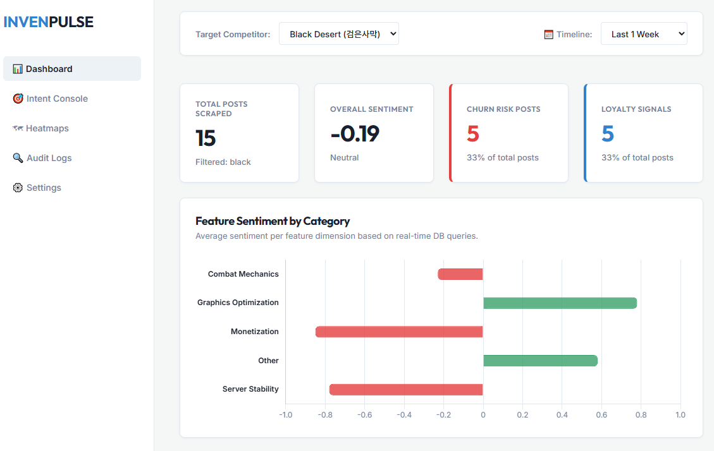
INVENPULSE Dashboard Reference 1.

- Intent Console
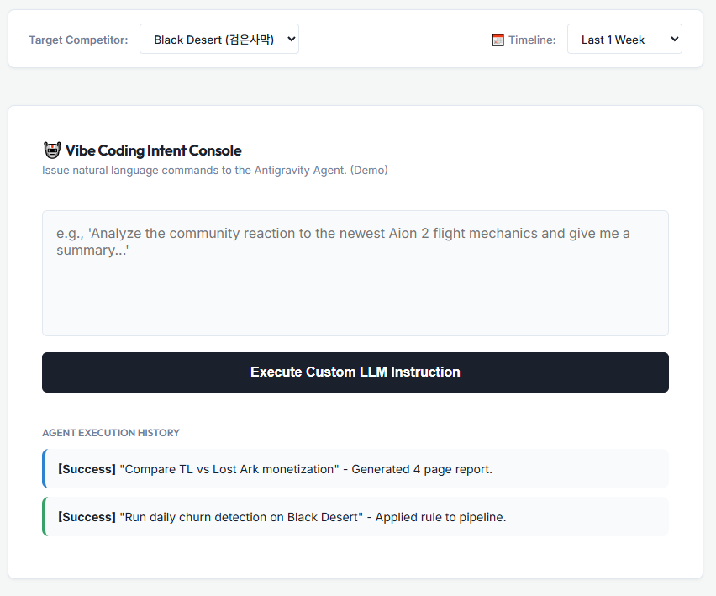
INVENPULSE Dashboard Reference 2.
- Heatmap
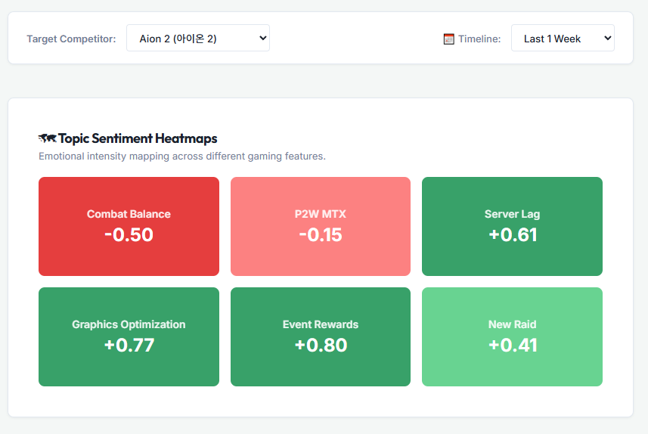
INVENPULSE Dashboard Reference 3.
- Audio Logs
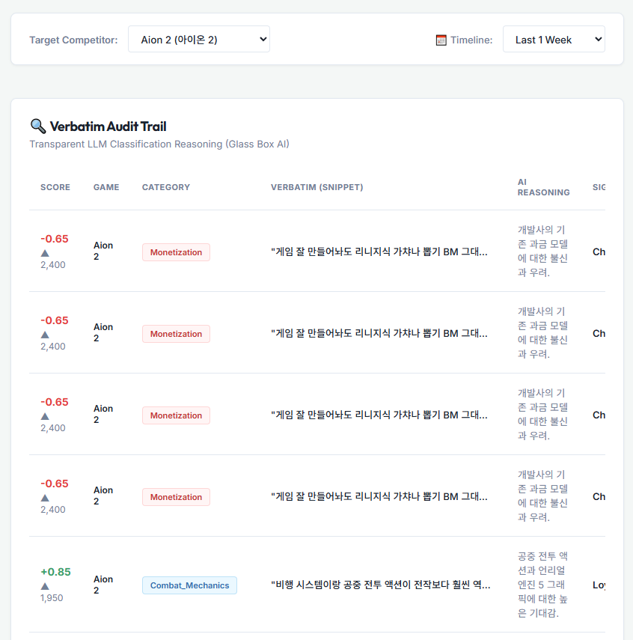
INVENPULSE Dashboard Reference 4.

6. Technical Architecture and Implementation Roadmap
The system architecture is designed as a multi-layered agentic framework that prioritizes Methodological Fidelity.
6.1. System Architecture Layers
- Semantic Layer (Input): Natural language prompts from the Intent Console are translated into technical scraping and classification tasks by the LLM controller .
- Agentic Controller (Antigravity): Manages the browser session, handling logins, pagination, and dynamic element expansion on Inven .
- Extraction Layer: Utilizes Autonomous Browser Actuation to pull hidden verbatims from sub-pages and long-form threads .
- Analytical Layer: Executes multi-dimensional classification (Combat, Monetization, etc.) and performs behavioral prediction using domain-specific sentiment markers .
- Audit Repository: Generates and stores Verification Artifacts (screenshots/logs) for every step taken by the agent.
6.2. Implementation Roadmap
- Step 1: Semantic Intent Mapping: Define the study scope in natural language (e.g., "Navigate the Lost Ark board and classify by feature") .
- Step 2: Environment Anchoring: The agent identifies CSS selectors for usernames, comments, and timestamps autonomously.
- Step 3: Iterative Prototyping (Vibe Coding): The researcher refines classification logic in real-time if initial results are too broad.
- Step 4: Verification and Artifact Audit: The researcher reviews reasoning logs to ensure the AI did not misinterpret sarcasm or gaming-specific slang.

7. Challenges and Best Practices
7.1. Data Privacy and Ethical Scraping
Researchers must ensure compliance with local regulations (e.g., Korea's PIPA) and community Terms of Service. Antigravity agents are programmed to respect robots.txt and anonymize user IDs during collection.
7.2. Mitigating Algorithmic Bias
If the training data is biased, the model will produce biased results. We recommend using diverse training sets and "Red Teaming" the agent's logic to ensure a balanced view of player sentiment.
7.3. Balancing Automation with Human Expertise
AI can categorize data, but only a human researcher can interpret the why behind the what. Custom tools should be seen as a complement to, not a replacement for, the researcher’s interpretive craft.
7.4. Broader Application Beyond Gaming
This "Maker" framework is highly portable across diverse categories:
- K-Beauty & E-commerce: Collecting Olive Young or Amazon reviews to analyze satisfaction with specific product "ingredients" or "texture" and tracking repurchase intent.
- Travel & F&B: Monitoring TripAdvisor or Yelp to identify "reasons for abandonment" and service quality over time to adjust operational strategies.

8. Conclusion: The Future of the Researcher-Designer
The integration of bespoke, agentic tools in market research marks a paradigm shift. By becoming "Makers," researchers reclaim their role as strategic partners who can navigate the complexities of digital culture with precision and speed. As we look to the future, the ability to design, adapt, and humanize the tools we use will be the defining skill of the next generation of insights professionals.

9. References
- Ahn, J. (2024). Navigating the Future of Consumer Insights with Custom-GPT. ESOMAR Final Paper.
- Davenport, T. H., & Ronanki, R. (2018). Artificial intelligence for the real world. Harvard Business Review, 96(1), 108-116.
- Jarrahi, M. H. (2018). Artificial intelligence and the future of work: Human-AI symbiosis in organizational decision making. Business Horizons, 61(4), 577-586.
- OpenAI. (2020). GPT-3: Language models are few-shot learners. arXiv.
- Patil, S. V. (2023). GPT for gaming world building: Success stories with GPT in e-sports. The AI Newsletter.
- West, D. M., & Allen, J. R. (2018). How artificial intelligence is transforming the world. Brookings Institution.

